16.2 Editors - Timeline - Channel list
Timeline - Channel List 1
Hotkeys 1
Search field 1
Expand / collapse triangle 1
Object type Icon 2
Channel name 2
Enable F-Curve Modifiers 2
Mute Channel 2
Lock Channel 2

Timeline - Channel List
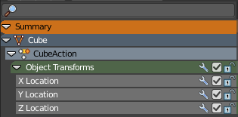
The channel list contains your objects and their animation channels. It is basically the same list than the one in the dope sheet editor.The timeline has no modes like the Dope Sheet though. And so you will just see the content from the dope sheet mode. And not shape key animation or grease pencil edit mode animation for example.

The channel list area is hidden by default. You need to reveal it by clicking at the small button up left. It can be resized by dragging the right border to left or right.

The list has several elements, to turn on or off different features, Or to expand or collapse the hierarchy.

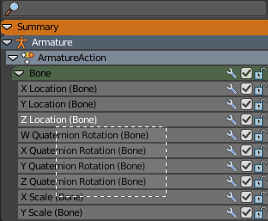
Hotkeys
Hotkey A selects all channels.
Hotkey Alt A deselects everything.
Left mouse and dragging activates box select.
Clicking at a channel selects it.
Clicking at a channel while holding down shift adds to the selection or removes from the selection.

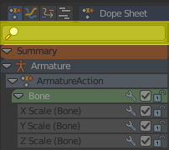
Search field
At the top is a search field that allows you to filter the channel list by search terms.

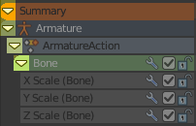
Expand / collapse triangle
The triangle icon at the left allows you to expand or collapse the hierarchy.

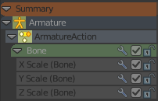
Object type Icon
This icon shows what kind of object this channel belongs to. These icons have no functionality.

Channel name
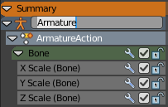
The name of the channel name and element. Some elements can be renamed. Like the action or object type.
To rename an element double click at it. Type in the new name. Then press Enter or click elsewhere.

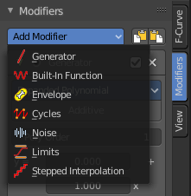
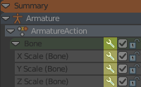
Enable F-Curve Modifiers
In the Graph editor you can add F-Curve modifiers. In the other animation editor types, like the Dope Sheet editor, you can enable or disable these modifiers by the Enable F-Curve Modifiers setting in the channel list.
For further informations about the F-Curve modifiers see the graph editor chapters.

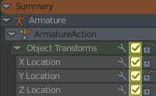
Mute Channel
Mutes the selected channel. It will not be calculated.

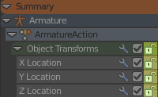
Lock Channel
Locks the selected channel. It is not longer editable.

